Erisa Trust Company

Consumer Portal Guide

WELCOME to your Erisa Trust Benefit Accounts Consumer Portal. This one-stop portal gives you 24/7 access to view information and manage your Health Savings Account.
Our one-stop portal provides you with:
- Anytime, anyplace access to your HSA, including online election changes and 24/7/365 availability to download HSA information, forms, and notifications
- Integrated access to your investment portal, meaning you only need to remember one username and password
- Fund performance and prospectus information for several available mutual funds
- Paperless administration, including online account summary reports
- Upload receipts and track expenses
I opened my Health Savings Account with Erisa Trust. What should I do now?
Go to the Consumer Portal today! www.HSAbyET.lh1ondemand.com
Register Online: Login with your username and password as provided for you in your introductory email. You will be prompted to update your password, complete security questions & sign your Terms & Conditions
Set up Investment Sweeps: You will be surprised at how quickly your account will grow! Be ready to maximize your account by setting up your account to sweep to investments automatically at $2,000 or higher. See “How do I sign up to Access/Sweep cash to Investments?” instructions on page 5.
- View up-to-the-minute account balances
- View your account activity details

We know from Web usage statistics that you’ll most likely use the portal to:
- Request distributions
- View account balances
- View account activity, including contributions, deductions, and payments
- View plan information, forms and notifications

This portal is designed to be easy to use and convenient. You have your choice of two ways to navigate this site:
- Work from sections within the Home Page, or
- Click on the six tabs at the top of the Home Page.

Contents

How do I log on to the home page? 3
Is there anything else that I need to do? 3
How do I request a distribution? 4
Can I contribute more funds to my HSA, other than payroll deposits? 5
How do I sign up to access/sweep cash to investments? 5
How do I find my investment balance? 5
All health care expense activity in one place 6
How do I add an expense to the dashboard? 6
How do I pay an expense? 7
How do I edit an existing expense in the dashboard? 7
Where do I find my investment detail? 8
Where do I find my investment balances? 8
How can I find my investment transaction detail? 9
How do I change my investment elections? 9
How do I transfer funds from one investment to another? 10
HSA Guidance 11
Strategy Builder 11
How do I view my payment history? 12
How do I report a debit card missing and/or request a new card? 12
How do I update my personal profile? 13
How do I change my login and/or password? 13
Are HSA statements available online? 13
Are HSA tax documents available online? 14
Where can I find HSA forms and resources? 14
How do I view or access plan information? 14
More Helpful Information 14

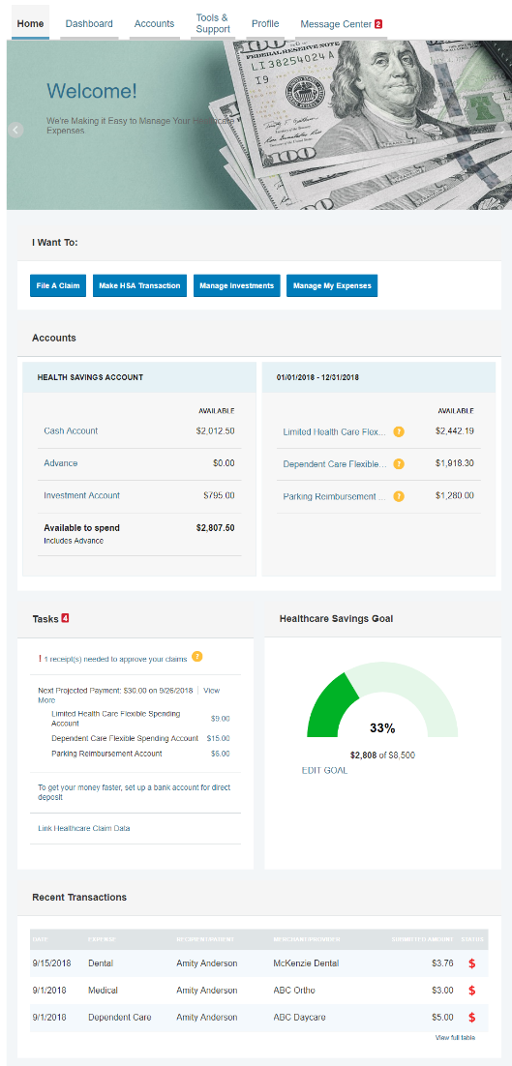
How do I log on to the home page?
- Go to www.HSAbyET.lh1ondemand.com
- Enter your login ID and password (both provided by Erisa Trust).
- Click Login.

The Home Page is easy to navigate:
- Easily access the Available Balance and “I Want To” sections to work with your account right away.
- The I Want To… section contains the most frequently used options within the Consumer Portal, including managing your investments.
- The Available Balance links to the Account Summary page, where you can see and manage your accounts.
- The Tasks section displays alerts and relevant links that enable you to keep current on your accounts.
- The Healthcare Savings Goal section graphically displays your HSA savings goals progress.
- The Quick View section graphically displays some of your key account information.

You can also click on the tabs at the top.

Is there anything else that I need to do?
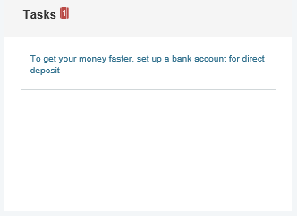
- Check Tasks; all messages are unique to each person’s profile
  - Have you set up Direct Deposit to get your money faster?
  - Have you downloaded the Mobile app for quick easy access to your account balance?
- An email notification will be sent alerting you that you have actions to complete opening your HSA account.

How do I request a distribution?
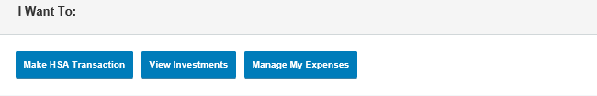
- To request distribution from your HSA, you may select the link in the “I want to…” section, Make HSA Transaction.
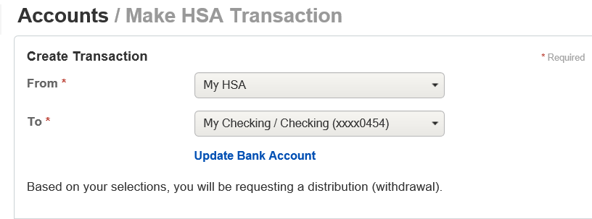
- To create a transaction from your HSA account, complete the fields as prompted through the online HSA transaction wizard. You may choose to receive a disbursement issued to yourself or, someone else.

- Did you know? For a convenient alternative, you can use your HSA debit card to pay for your medical expenses directly from your HSA.

The fastest way to get your money is to use your HSA debit card at the point of sale to pay for expenses. If you did not use your debit card, the quickest way to receive reimbursement is to sign up online for direct deposit to your personal checking account. Before you begin, make sure that your employer is offering direct deposit setup online.
- From the Home Page, under the Tools & Support tab, click Change Payment Method under the “How Do I” section.
- Select Reimburse Myself Using Direct Deposit and click Change Payment Method. The Add Bank Account: Direct Deposit Setup page displays.
- Enter your bank account information, and click Submit.
- The Payment Method Changed confirmation displays.
- If there is a bank validation requirement, you will be notified on the portal to look for a small transaction or “micro-deposit” in your designated bank account in the next couple of days to enter online, which will validate your account.
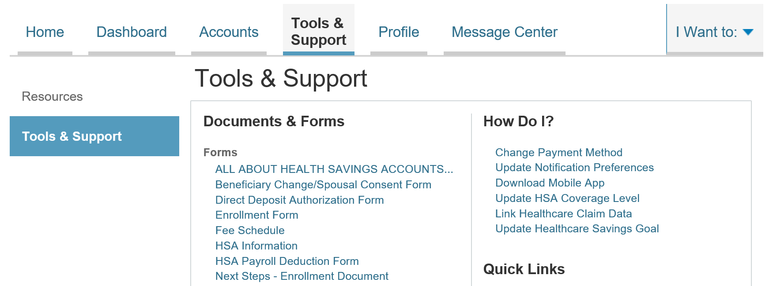

Can I contribute more funds to my HSA, other than payroll deposits?
Yes! You may contribute to your HSA by transferring from your personal bank account, and then report that contribution on your tax returns to claim your deduction at tax filing time.
- To make a personal contribution from a personal banking account to your HSA, you may select the link in the “I want to…” section, Make HSA Transaction.
- If you have a bank account on file, you may use that as your contribution account. If you do not then there is a link to add a new bank account.
- You may make a one-time or recurring contribution as you wish! Complete the transaction information and follow the remaining steps of the online HSA transaction wizard.
- The debit will hit your personal bank account within 2 business days of your request, and the money becomes available in your HSA as soon as it is deposited.

How do I sign up to access/sweep cash to investments?
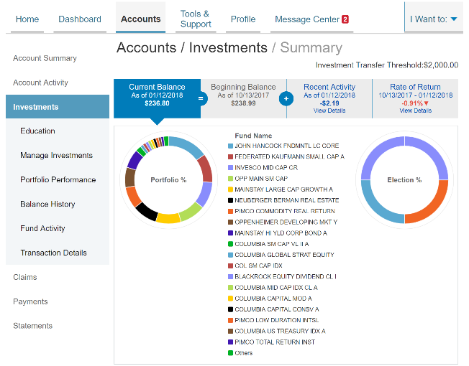
- From the home page, access the Investments Summary page by clicking on the Manage Investments button from the “I want to section”
- Once you get to the summary page, select the Manage Investments button on the left-hand side of the screen.
- Select Update next to Auto-Transfers to or from an Investment Account.
- Enter the dollar amount (above the noted minimum) to set as a ‘cash threshold balance’ for your investments to automatically transfer between cash and investments ongoing. You can change this at any time!
- Don’t forget to set your investment allocation!! See “How do I change my Investment Elections?” below.

How do I find my investment balance?
You can find your HSA cash and investment balances directly from the home page under the Available Balance section on the left-hand side of the screen. For more details click on Available balance and select Account Activity. From there, you can view even more detail regarding your account.

All health care expense activity in one place
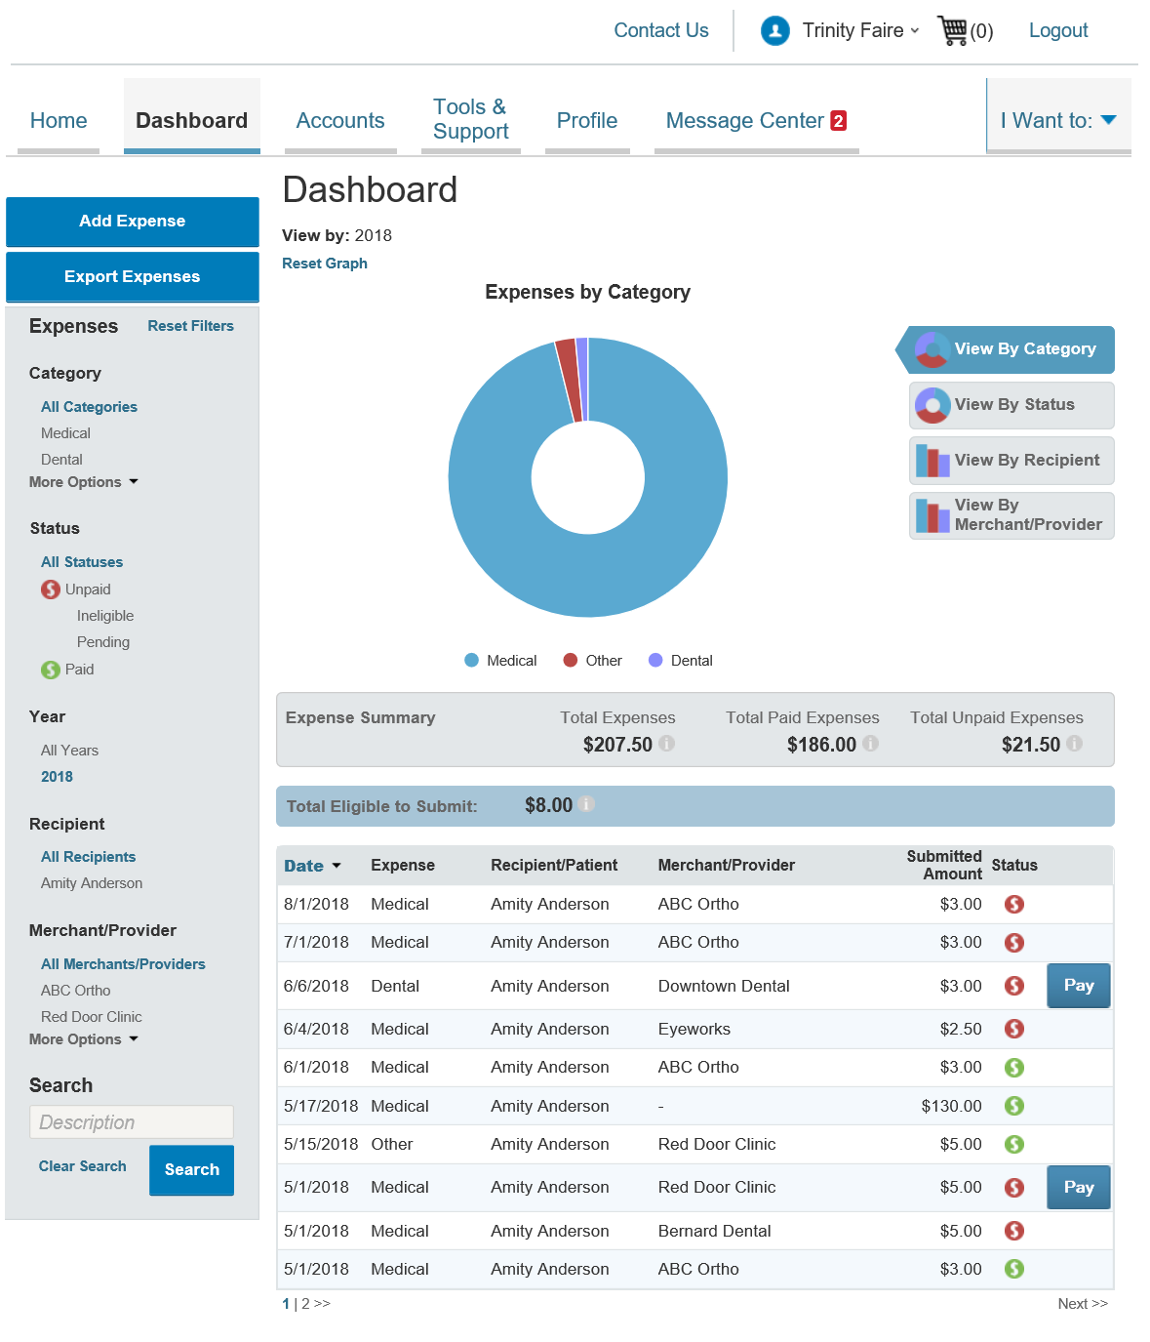
To view and manage healthcare expense activity, use the Dashboard
- From the Home Page, under the Dashboard tab the Dashboard provides you with an easy-to-use consolidated view of healthcare expenses for ongoing management of medical claims, premiums, and card transactions.
- Easily filter expenses by clicking on the filter options on the left-hand navigation pane or, by clicking on the field headers within the Dashboard.
- You can search for specific expenses using the search field on the bottom left-hand side of the screen.
- Expenses can be exported into an Excel spreadsheet by clicking on the Export Expenses button on the upper left-hand side of the page.

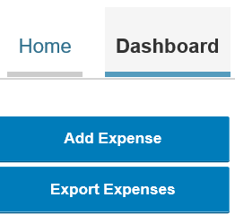
How do I add an expense to the dashboard?
- From the Dashboard click on the Add Expense button in the upper left-hand side of the page.
- Complete the expense detail fields. You can even upload a copy of the receipt and, add notes for your records.
- Once the expense has been added to the dashboard you can pay the expense, if desired.

How do I pay an expense?
- You may process payments/ reimbursements for unpaid expenses directly from the Dashboard page.
- Expenses will be categorized and payment can be initiated for unpaid expenses by clicking on the button to the to the right of the expense details.
- You can filter the Dashboard to only view unpaid expenses by clicking on the unpaid status from the navigation bar on the left-hand side of the screen.
- Simply choose which expenses you would like paid and you will be presented with the eligible accounts to select where the claim should be paid.
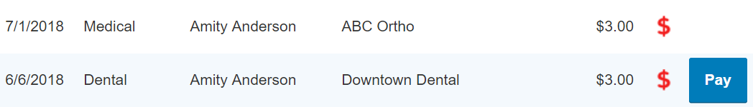
- When you click Pay the claim details from the dashboard will be pre-populated within the claim form. Review & edit the claim details by completing any required fields that remain blank.
- You will have the option to either request a reimbursement/distribution to yourself or, pay the provider.

How do I edit an existing expense in the dashboard?
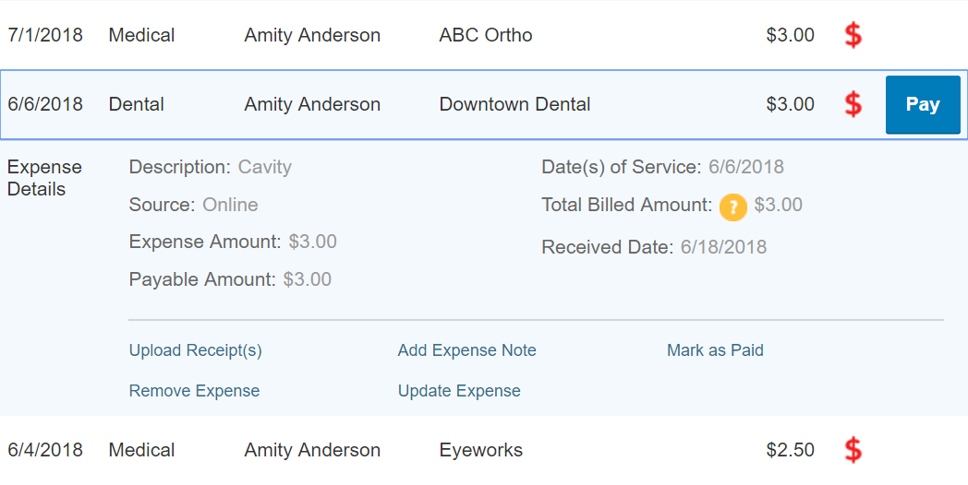
- You can edit expense details for all claim statuses directly from the Dashboard page.
- Expand the expense details visible by clicking on the expense line item from the Dashboard.
- You will be presented with options to add expense notes, update the expense details, mark the expense as paid/unpaid or, remove the expense for unpaid expenses from the dashboard.

Where do I find my investment detail?
From the Homepage, click on the Manage Investments button under the “I want to section”. The Investment Summary page provides you with a dynamic snap shot view of your investment account. The menu on the left-hand side allows you to drill down into specific details regarding your investment account.

Where do I find my investment balances?
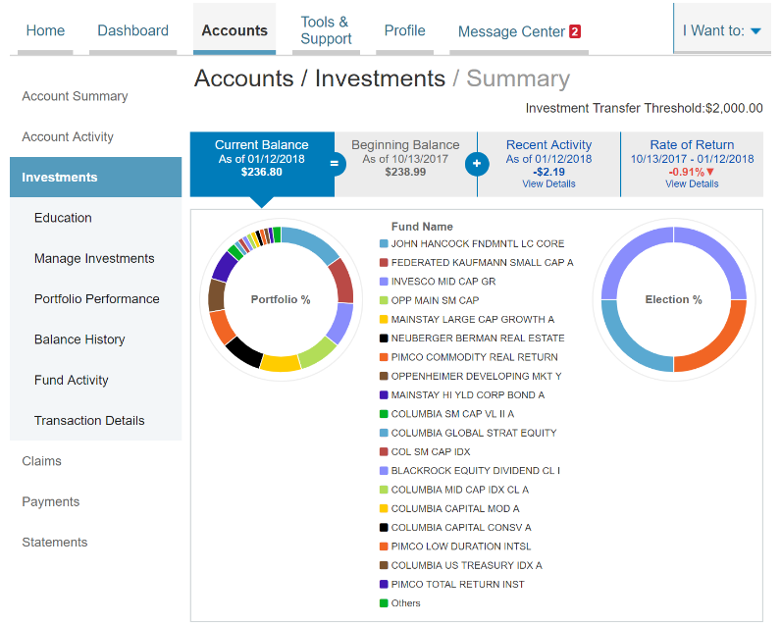
From the Investment Summary page, click on the Balance History. Use the filters to provide you with specific balance information related to your investments.

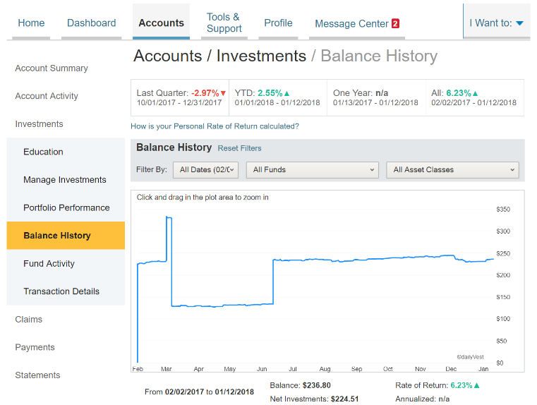

How can I find my investment transaction detail?
From the Investment Summary, click on the Transaction Details, and select Transaction Details.

How do I change my investment elections?
To setup or change your investment elections for future contributions to your investment account, click on the Manage Investment from the Investments Summary page.

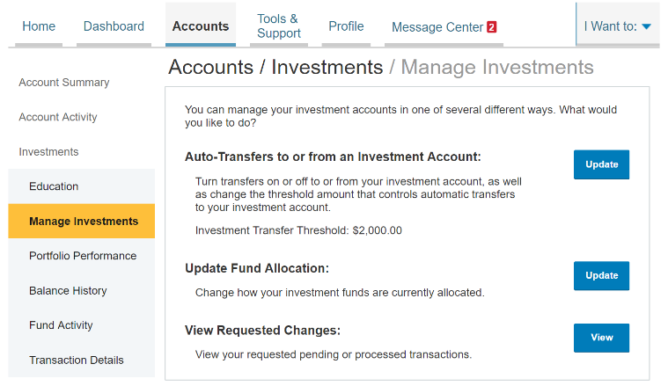

Click on the submenu Manage My Investment Account and select Update Investment Elections on the investment portal. If you do not choose specific investments, 100% of any contributions will be in the HCB Interest Bearing Account as noted on the first line. You can choose to allocate funds among any of the investment options listed by entering the specific percentage in the box to the right. Please note any changes you make will affect your investment elections for future contributions but will not change how the current balance in your HSA is invested.

How do I transfer funds from one investment to another?
To make changes to existing investment balances, you can user either the Realign Portfolio & Update Elections or Realign Portfolio option under Manage Investments.

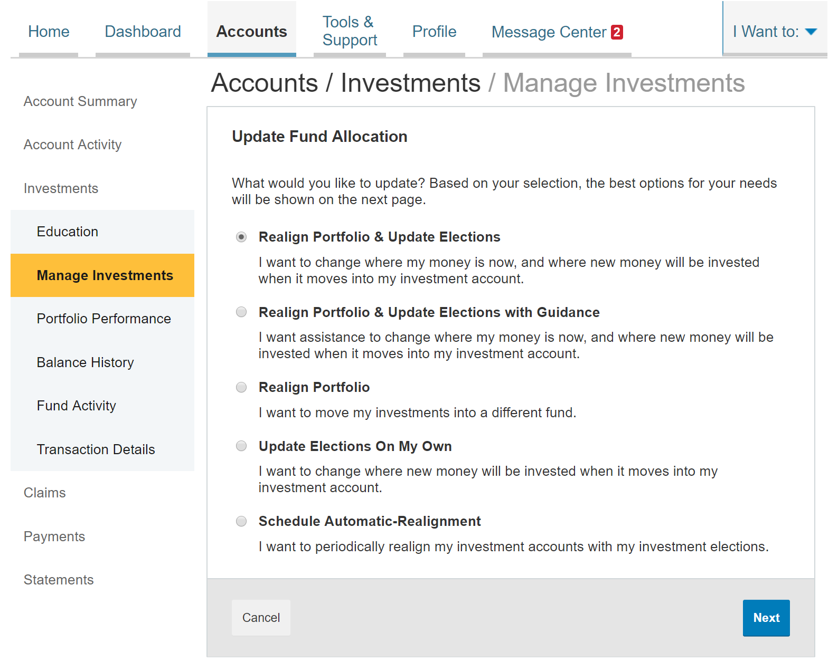
Realign Portfolio & Update Elections affects your entire account balance. A realignment initiates the sale of your existing investments and reinvests the proceeds according to your new investment instructions. Trades initiated before the market closes (3:00 p.m. CST) will be processed the same business day. Trades initiated after the market closes are processed at the close of the next business day.

Realign Portfolio initiates a sale of one or more funds and a purchase into another fund or funds. Trades initiated before the market closes (3:00 p.m. CST) will be processed the same business day. Trades initiated after the market closes are processed at the close of the next business day.
Note: Realign Portfolio will not change your investment elections for future contributions to your investment account. See the previous question and answer for steps to change elections for future contributions.

HSA Guidance
An Investment Guidance Help – Guidance on Selecting Investments
Click on the Manage My Investment Account tab and it will bring you to a separate page where you can develop your personalized HSA investment strategy for your HSA investment account, based on your own unique circumstances.
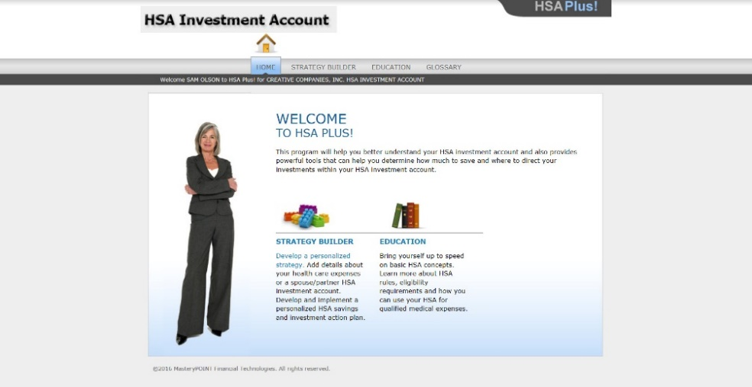

Strategy Builder
Develop your own personalized Action Plan
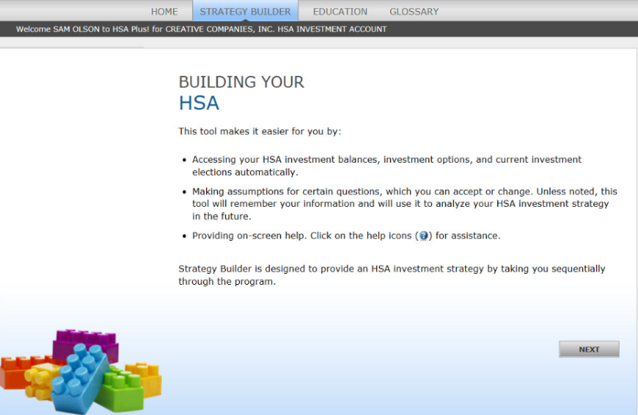

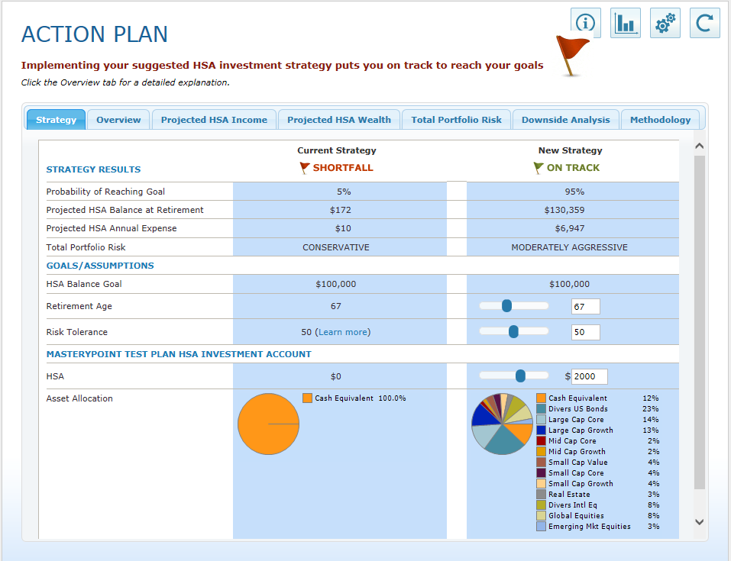

[EDUCATION]
Polish up on HSA concepts and learn more about HSA rules, eligibility requirements and how to use your HSA for qualified expenses
[GLOSSARY]
HSA terms to familiarize yourself with

How do I view my payment history?
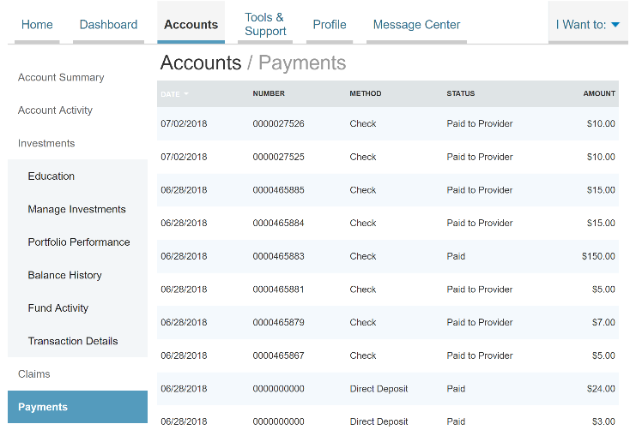
- On the Home Page, under the Accounts tab, click Payments from the Left-hand menu.
- You will see payments made to date, including debit card transactions.

How do I report a debit card missing and/or request a new card?
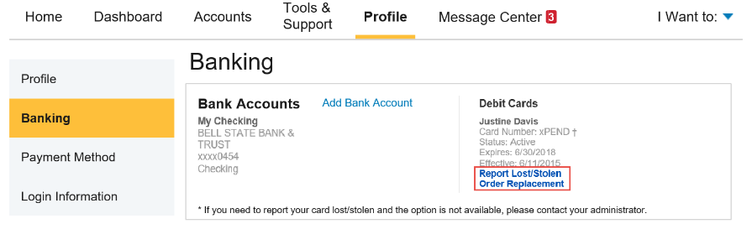
- From the Home Page, under the Profile tab, click the Banking/Cards link on the left-hand side of the screen
- Under the Debit Cards column, click Report Lost/Stolen or Order Replacement and follow instructions.

How do I update my personal profile?
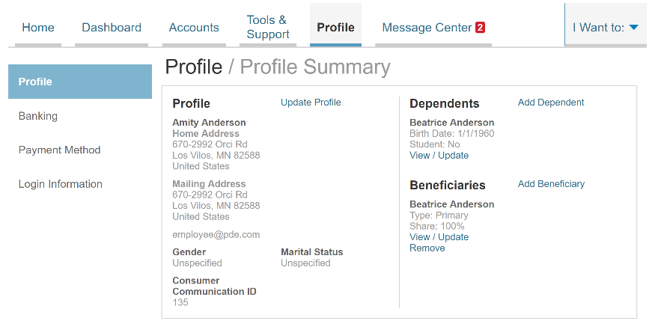
- From the Home Page, under the Profile, you will find links to update profile information including profile summary details, dependents, and beneficiaries.
- Click the appropriate link on the Profile screen for your updates: Update Profile or Add/Update Dependent or Add Beneficiary. Some profile changes will require you to answer an additional security question.
- Complete your changes in the form.
- Click Submit.

How do I change my login and/or password?
- From the Home Page, click on the Profile tab, and click Login Information on the left-hand navigation bar.
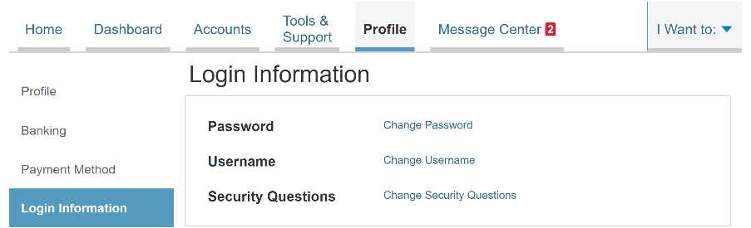
- Follow instructions on the screen. (For a new account, the first time you log in, you will be prompted to change the password that was assigned by your plan administrator. Follow the instructions.)
- Click Save.

Are HSA statements available online?
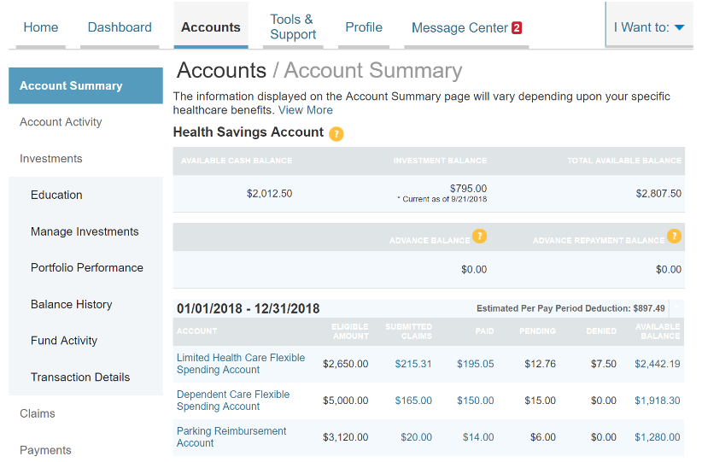
Your HSA Account Summary report can be found by clicking on the Accounts tab and selecting Statements. The three most recent summaries will be displayed or, you can click on view all to see more.
An HSA Investment Account summary can be found on the Investment Portal by choosing Fund Activity Summary.

Are HSA tax documents available online?
Your HSA Tax Documents can be found by clicking on the Tools and Support tab and choosing HSA Tax Documents. All tax documents will be accessible here, including corrections or updates.

Where can I find HSA forms and resources?
Forms, such those pertaining to HSA distributions and excess contributions, can be found under the Tools & Support tab. Additional resources, such as FAQ’s, and information about interest rates and how to invest funds can also be found under the Tools & Support tab.

How do I view or access plan information?
- From the Home Page, under the Accounts tab, you will be directed to the Account Summary page
- Click the applicable account name and the Plan Rules will open in a pop-up window.
OR from the Home Page, under the Tools & Support tab, you may view Plan Summaries for basic information. Then click each applicable plan to see the plan details.
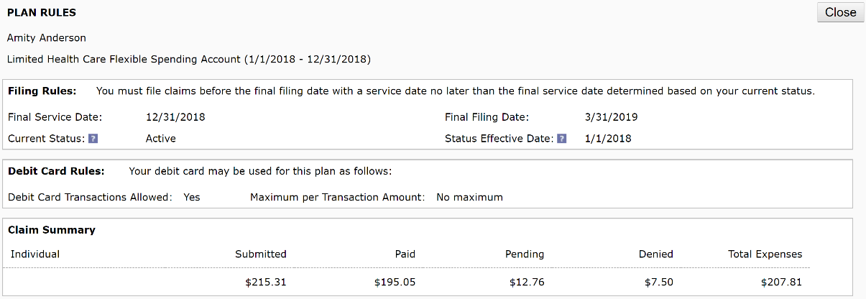

More Helpful Information
From the Home Page, under the Tools & Support tab, you may find links that connect you to helpful information supplied by your Erisa Trust administrator. These may be links to your account administrator’s website or to other valuable resources that enable you to manage your healthcare more effectively.

